Fall 2014 Senior Design Proposal

Group 2

Prepared for:

Dr. Latcha

Dr. Gu

By:

Paul Kruchko (EE), Project Manager

Michael Laba (ME), Mechanical Design Team Lead

Bryan Jagielo (EE/CE), Electrical and Controls Team Lead

Xiaoang Tong (EE)

Monika Shaeff (CE)

Ran Ao (ME)

Xinfeng Shi (ME)

September 23, 2014

**Introduction**

Senior Design Group 2 was assigned the task of constructing a machine that could efficiently and accurately count parts needed by an assembly worker and dispense those parts into a worker’s awaiting hand, thereby reducing the chance of parts being dropped on the floor and discarded. This proposed device has the potential for optimizing throughput time in the assembly process while saving money in lost and discarded parts.

**Proposed System**

The system that Group 2 proposes is a closed-loop, feed-back, electronically controlled vibratory bowl feeder that agitates, actuates, and organizes a set of homogenous hardware components that are to be counted and dispensed into the awaiting hands of the operator/user.

The overall structure of the system is a bowl that serves as a hopper and transducer placed at the rear-end of the system. Inside the bowl is a spline that ascends to the top of the bowl and narrows along its path. Meeting the spline at the top of the bowl is a PVC tube and a control gate that is attached to an RC servo motor. Attached to the tube are 6 pairs of diametrically opposing photo electronic sensors, evenly spaced to count parts to be dispensed and measure the velocity of those parts. Waiting at the end of the tube is a staging trough that can dump the counted parts into the dispense funnel or into the reject bin. At the front end of the system is a flat panel that contains the user interface (UI) and dispense door. The UI consists of; a red lamp and a green lamp, a 2x16 LCD display, a six position granulated turn knob, a “Start” button, a “Load” button, a “Select” button, a “Up” button, a “Down button” and a NEMA certified emergency stop button. At the bottom of the front panel is a door that the user must push in with his/her hand to receive the requested number of parts.

The overall theory of operation of the system is that the user would deposit no more than 50 parts at a time in the vibratory bowl, which doubles as a hopper. Once the user has deposited the parts to be counted and dispensed into the bowl, the user would initiate the load sequence of the machine by pressing the “Load” button. Then the machine would output on the LCD screen, “Please select a part.” The user would then select the profile of the part using the “Up” and “Down” keys and once the desired part was displayed on the LCD screen the user would then press the “Select” button. The loading sequence would cause the vibratory action of the bowl to begin and agitate the parts in the bottom of the bowl to start to move along the dispense path. During the loading sequence the red lamp is illuminated and the LCD displays, “Loading…”

This vibratory action is produced by periodically energizing a pair of opposing electromagnets in the base of the bowl. The bowl itself would be mounted to a cross member that would have two armatures attached to it that would be pulled towards the electromagnets when energized. The motion due to magnetic forces would then be complimented by a pair of leaf springs that would snap the bowl back into its original position on the de-energized state of the electromagnets. This periodic motion would produce a coupled moment on the bowl that would then be transferred to the parts inside.

The moment produced would cause a mass flow rate of the parts to begin, with the moment turning into a normal and tangential angular acceleration on the individual parts. The tangential acceleration on the masses would produce a force that would cause the individual parts, collectively, to move along a spiral path ascending up the sides of the bowl. The spiral path would then begin to narrow, forcing individual parts more into a single line. A height deflector would then be placed in the path to deflect parts that have vertically stacked on top of each other off of the main path, and back into the bowl. In addition to a height deflector, an agitator stick would be connected to the side of the bowl, with the sole purpose of knocking the longer screws and items into one of two orientations, allowing them to be perfectly lined up with each other length-wise. These length-wise and single-file arrangements would cause the order of the parts to be more conducive to counting by way of the photo-electronic sensors.

Once the parts have been ordered into a single file line they are forced into a channel at the top of the bowl and at the end of the path, the width of which is manually adjusted by a block plunger system that is fixed in between two mounting brackets that have holes set at the right width for a given part. At the end of channel are a capacitive proximity sensor and a control gate mounted onto an RC servo motor. The vibratory motion continues to maintain the density of the mass flow to guarantee instantaneous system response. The control gate keeps the agitated parts from moving forward and down into the transfer tube until user input is received.

When the capacitive proxy sensor senses the presence of the first part the red lamp is extinguished and the green lamp is illuminated to indicate that the system is ready to start dispensing parts and the LCD displays, “Please select quantity and press ‘Select’”. At this point the user rotates the number of parts desired from 1 to 6. Once the user has selected the desired quantity of parts to be dispensed by way of the granulated knob he/she would then press the “Select” button initiating the count and dispense sequence. At that time the green lamp would extinguish and the red one illuminate. The LCD would display, “Dispensing parts, please wait…” During the count cycle the control gate swings open and allows the parts to fall into the funnel for the transfer tube. During the descent of the part through the transfer tube the beam of the photo-electronic sensor array is broken as the falling part passes through triggering the corresponding port on the microcontroller. The count is determined by the breaking of any of the beams in the array, while the velocity of the falling part is determined by counting the time of the breaking of the first beam and all of the subsequent beams given the fixed distances between them. The microcontroller calculates the velocity of the part by dividing the distance between the sensors by the mean average time difference that the beams of the sensors were broken. The velocity that is measured and calculated by the microcontroller controls the frequency of the pulsing electromagnets which controls the rate of the mass flow, this way the system is able to automatically adjust its own speed. This guarantees that the system dispenses the parts slow enough for an accurate count, but fast enough for a timely dispense cycle. Each part will have a profile programmed into the microcontroller. This profile includes the velocity that the part should be descending through the transfer tube. This velocity also allows the microcontroller to sense an error condition has occurred if the part selected does not match the velocity profile of the part being dispensed. If this is the case then the microcontroller can reject what has been dispensed already by actuating the staging trough to rotate to the discard direction to discard any contents into the reject bin. This causes the microcontroller to close the control gate, actuate the staging table into the discard mode then re-attempt the count cycle again. If the count cycle fails three times in a row then the system will alert the user by displaying a message on the LCD that reads, ”Catastrophic error, please conduct remedial actions.” If this is the case then then it would be necessary for the user to visually inspect the cause of the error. This would most likely not be the case, but there is error handling designed into the system and an NEMA compliant emergency stop button, that when pressed cuts-off system power so that if any error occurred it could be safely inspected.

Once the successful count cycle has finished the desired quantity of parts would be staged waiting in the staging trough. Once the system senses that the desired quantity of parts have been dispensed and that no error conditions exists, then the trough would be rotated to the dispense side, allowing the parts to fall through the dispense funnel and into the dispense cup. Once the parts are dropped into the dispense cup the system would extinguish the red light and illuminate the green light. A message on the LCD would display, “Please push in dispense door to receive parts…” Once the user pushes in the dispense door a transfer rod causes a pivot arm to push the cup forward by another transfer rod and the cup slides forward over the final dispense funnel. The cup itself is bottomless, with only a plate beneath it when the parts are being dropped in from the staging table. This allows the parts to fall through the bottom of the dispense cup, through the dispense chute, and into the awaiting hand of the user. The door/cup system employs the use of limit switches to determine if the user has fully-actuated the door or not. If the user does not claim the parts the system will wait indefinitely until the user claims the parts. Once the user claims the parts the system is reset and ready to receive another selection or be loaded with a different type of part

**Diagrams and Sketches**

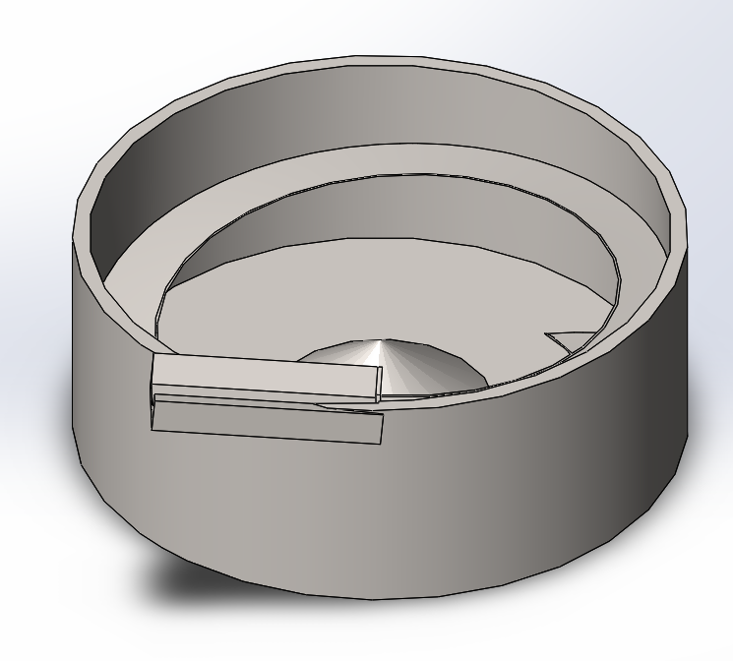**Key Mechanical Components:**

1. 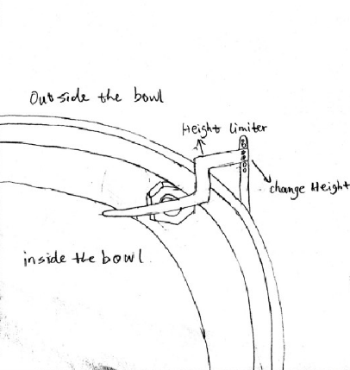Bowl feeder - serves as a hopper and transducer placed at the rear-end of the system

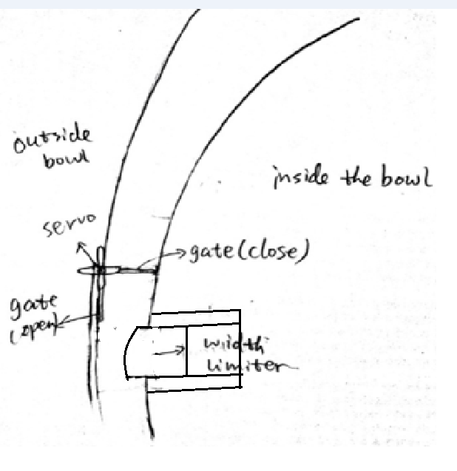

1. Inside the bowl - a control gate that is attached to an RC servo motor, and the spline that ascends to the top of the bowl and narrows along its path.

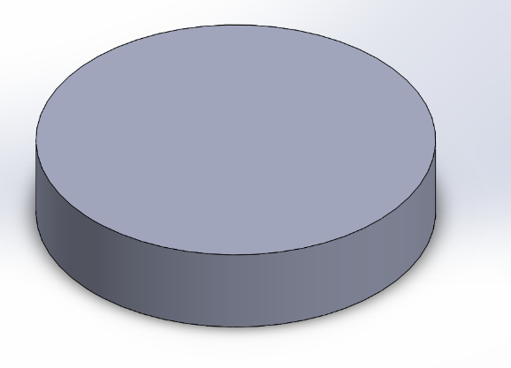

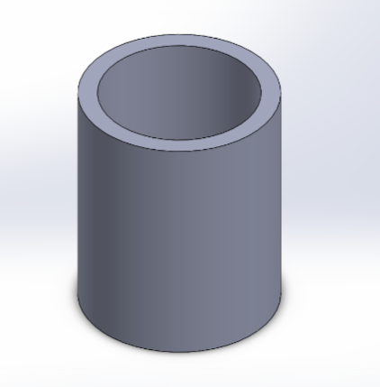3. Counter weight - The vibratory action of the bowl to begin and agitate the parts in the bottom of the bowl to start to move along the dispense path.

4. Parts counting chute - Attached to the tube are 6 pairs of diametrically opposing photo electronic sensors, evenly spaced to count parts to be dispensed and measure the velocity of those parts.

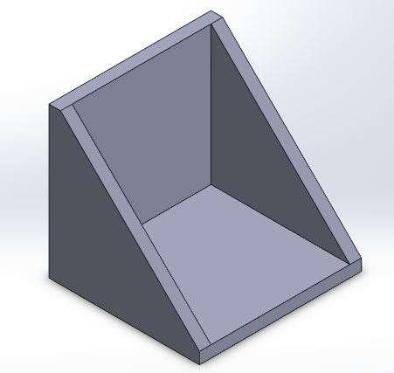

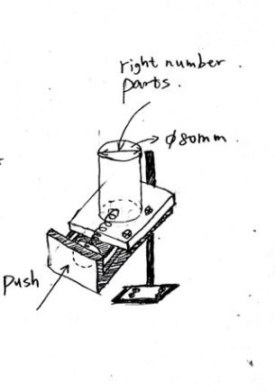

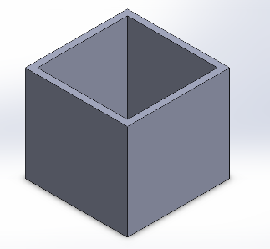

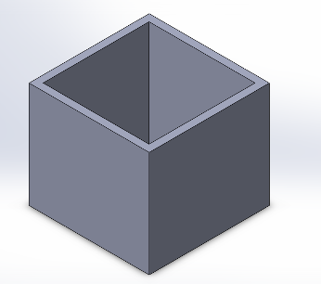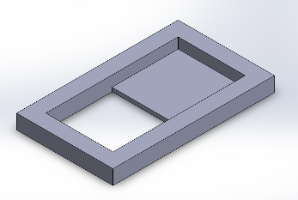

5. Count staging part, rejection bin, and presentation bin.

**Frame Assembly**

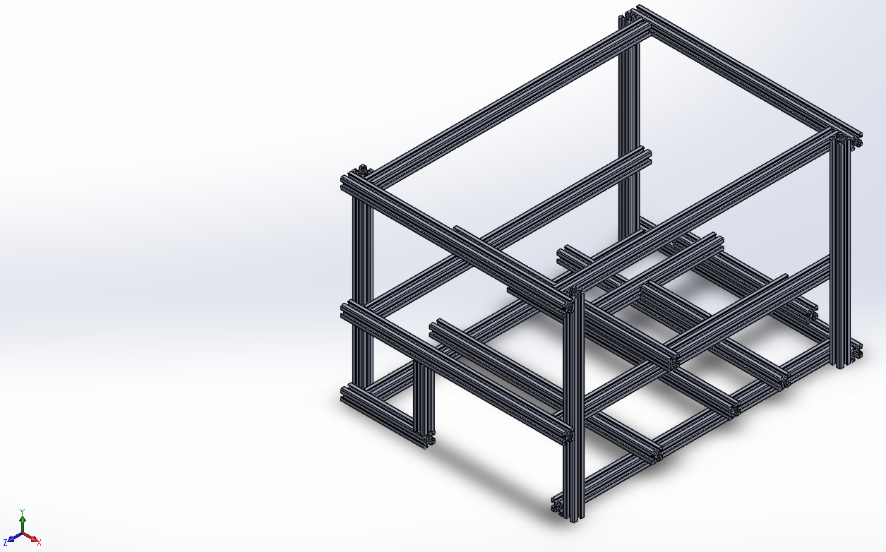

*All 80/20 CADD models found on www.8020.net

6. Frame uses 20mm X 20mm aluminum 80/20 beams. That can be cut to length and fixed to support the rest of the assembly inside.

**Final Assembly**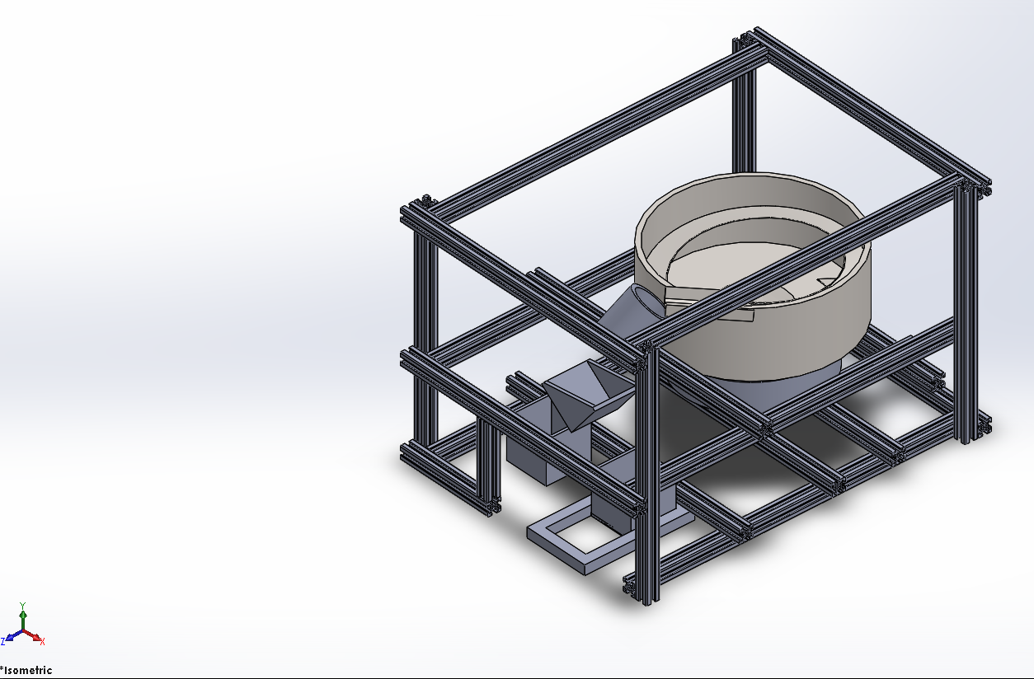

7. The final picture of all the components in their relative positions.

**Electrical and Electronic Components:**

8. Microcontoller selection: Arduino Mega 2560 R3

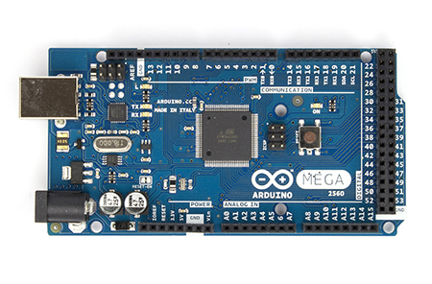

*Arduino Mega 2560 R3 Front\**

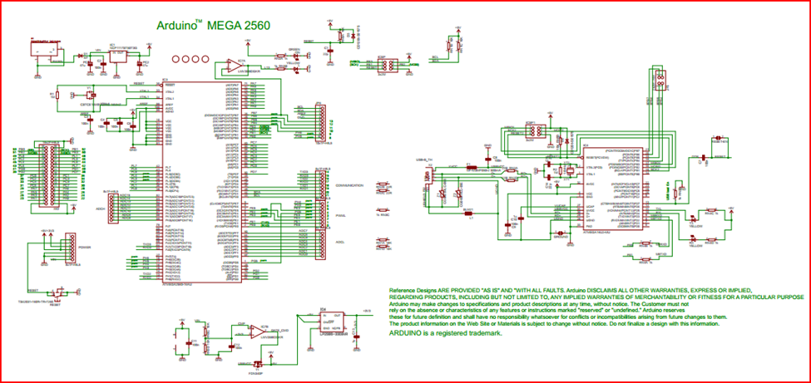

**Arduino Mega 2560 R3 Electrical Schematic\***

*Arduino Mega 2560 R3 schematic and picture gleaned from http://arduino.cc/en/Main/ArduinoBoardMega2560

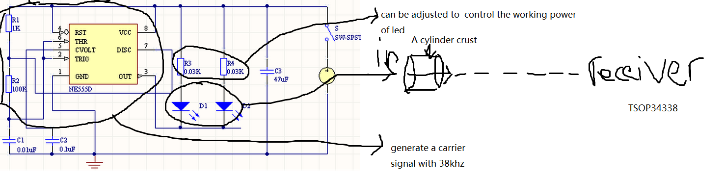

**Light Sensor Driving Circuit Concept Sketch**

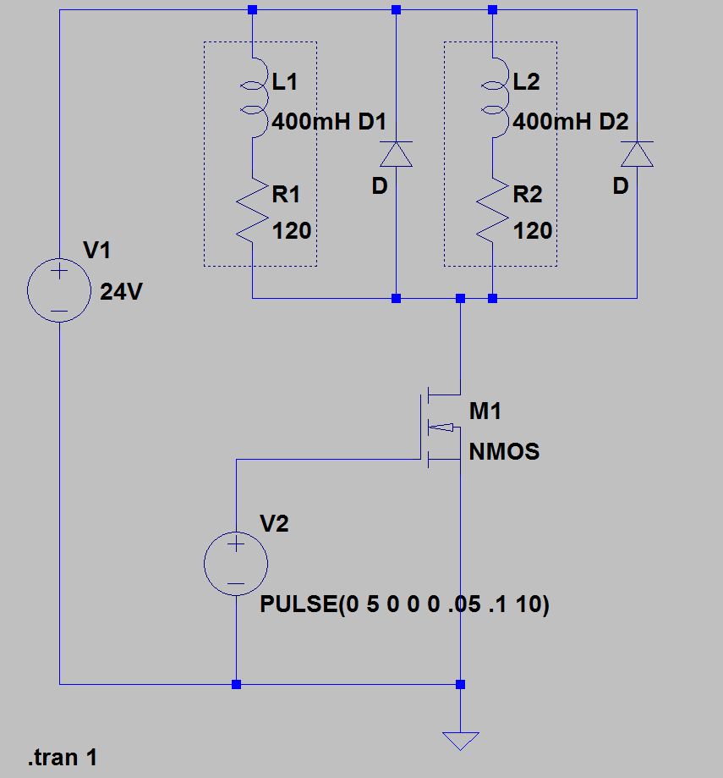

**Solenoid Driving Circuit**

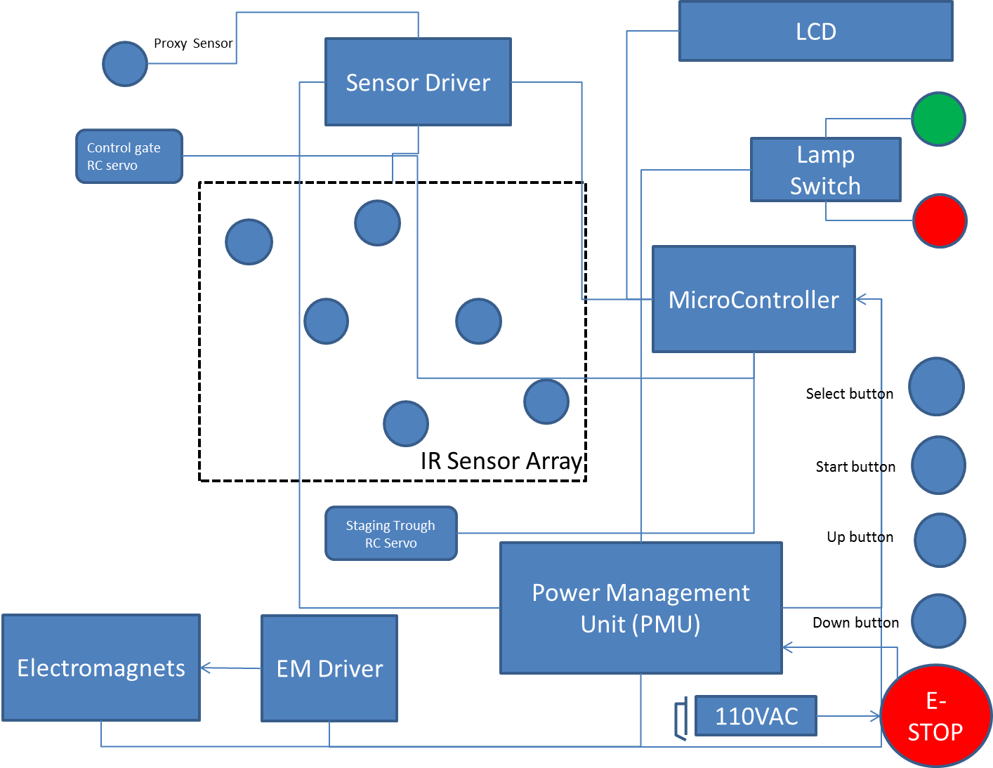

**Electrical Component Intercabling Diagram**

**Expected Specifications and Features**

**1. Using IR led to make Ir emit and receive system**

**IR sensor working principal:**

IR light wave which is generated by IR led emit from IR emitter will catch by IR receive when emitter and receiver are setting in horizontal line. Therefore, if something goes through between emitter and receiver the item will block the light and the state of receiver will change, and then the counter will be count. We choose to use 38KHZ carrier wave to transport IR light to avoid the noise and some other disturb in the external environment.

Components: A 5mm IR led, IR receiver: TSOP34338, Timer IC: ne555d, Cylinder crust.

Resister, capacity, and wires

It is not necessary to add a lens in emit system, because IR led has already had similar structure.

**IR led : IR333-A**

Features

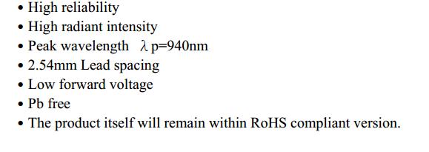

**IR receiver: TSOP34338**

Features:

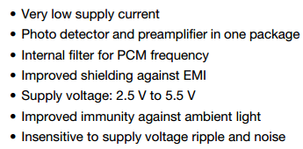

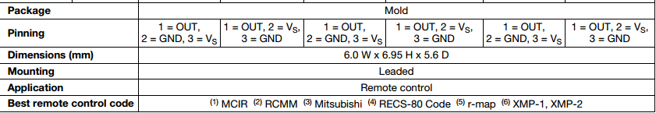

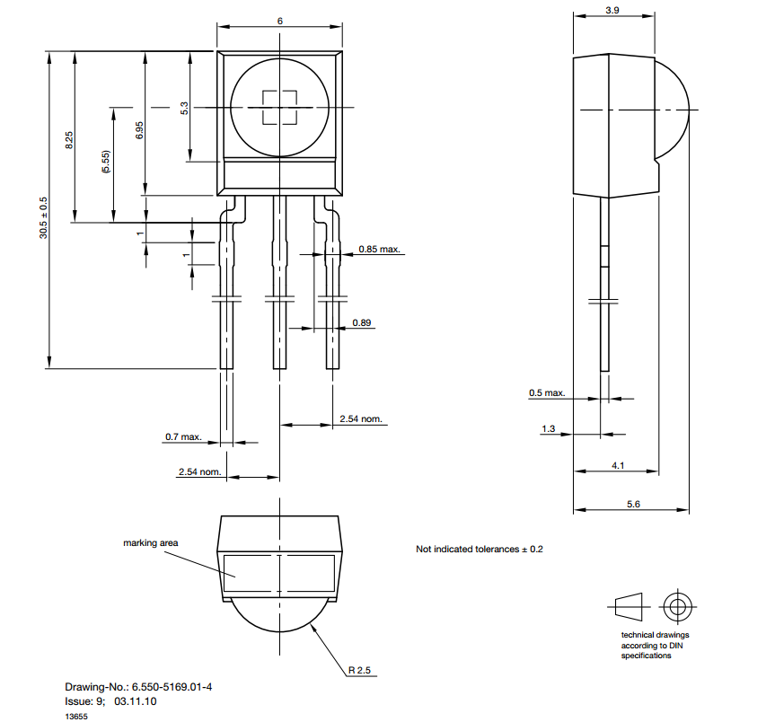

**3. proximity sensor depend on capacitive proximity sensor**

Capacitive proximity sensor working principal:

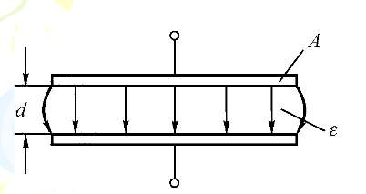

C=ε*s(available area)/d(distance between pole)

Application: proximity sensor

Work principal: by detecting the variation of capacity value when the item pass the capacitive proximity sensor to get the output signal. Then utilize this variational signal to change the system work state after amplify, rectify, and trigger.

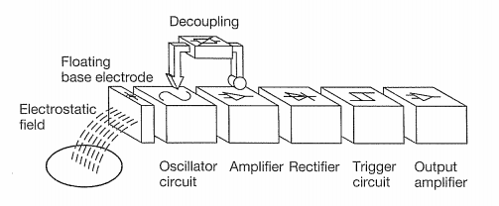

We don’t decide which model of capacitive proximity sensor we will use right now.

Microcontroller Specifications*

|  |  |
| --- | --- |
| **PRODUCT INFORMATION** | |
| SKU | 194746 |
| Mfr Part# | 194159 |
| UPC | 618996977871 |
| **BOARDS/PROJECTS** | |
| Board Type | Arduino Mega2560 |
| Components | Mainboards |
| **MAINBOARDS** | |
| Board Color | Blue |
| Processor | ATmega2560 Microcontroller |
| Clock Rate | 16MHz |
| Operating Voltage | 5V |
| Input Voltage | 7V - 12V |
| Input Voltage (Limits) | 6V - 20V |
| Digital I/O Pins | 54 (of which 15 provide PWM output) |
| Analog Input Pins | 16 Pins |
| DC Current per I/O Pin | 40mA |
| DC Current for 3.3V Pin | 50mA |
| Flash Memory | 256KB |
| SDRAM | 8KB |
| EEPROM | 4KB |
| **WHAT IS IN THE BOX** | |
| What's in the Box | Arduino Mega 2560 |

*Specifications gleaned from http://www.microcenter.com/product/431995/Arduino_Mega_2560

**Design Considerations**

In order to come up with our design extensive research was done to see how parts are moved, counted, stored, contained and controlled in real world settings. After exploring some examples we started to consider our own design additions to make or add to designs that would in theory mimic the results of massive modern parts counting machines. We took away key pieces that each machine seemed to achieve to make it successful.

In order to choose a design, a chart was created for each feature that would have to take place in the machine. The events were ordered to follow the path of a single small part through each step in the machine’s processes. Where each step would need to physically be controlled and have the capability for an electrical system to view and provide feedback to the machine’s main electrical controls.

In order to hold the parts the machine needed a larger bin or space that could feed parts to the rest of the machine. The model of the bowl feeder design could hold large amounts of small parts and would be providing continuous feeding to the machine. Other hopper designs where considered however, it was deemed not necessary due to the expected part volume being too small to add another major part storage device.

The machine has to be able to physically move the small parts from the hopper to the rest of the machine, and it must do so efficiently and orderly. In order to move the parts, many examples that were observed used vibration methods, conveyor belts, rail systems and good old gravity. It was decided for this machine to attempt the vibration method due to most methods vibrated a bowl and ramp system which allowed for moving parts, storing parts and separating parts by orientation.

From the systems major flow of parts the amount of parts exiting the upstream portion of the machine was limiting the flow by means of spaces and gaps that would allow parts of one orientation to move through without falling back into the main population at the bottom of the bowl. These limitations allowed for a single oriented and controlled line of parts to be fed to the rest of the machine. For this project the machine will use a height limiter to prevent stacking of parts, an angled flow limiter to put parts into single file and a gate which will allow for the flow to be cut off from the rest of the machine when needed. It has been taken into consideration that each limiter will have manual adjusters in order to set up the limiters to handle different part sizes and shapes moving through the machine.

Once oriented and position to a single feed made slower accurate counting easier. It has been noted that some machines can count multiple small parts moving out to the machine at once, however the accuracy of the count and the speed of the machine have been deemed a risk to our application. It is recognized that this machine has been made to count slower and more times to ensure accuracy and control. The quantity that we need is finite and relatively small compared to machines counting 2000 parts a minute making counting this fast unnecessary. It is decided to use multiple sensors so that we can read multiple counts and compare counts to determine the correct count in the machine. The spacing and orientation of the sensors is a critical matter to be calculated, measured, and considered. To be on the safe side, we are counting and holding in a separate holder. If the count is correct the count will be dumped into an area that is waiting for user input. If the count is incorrect then the count will be put into a rejection bin where the parts can be manually put back into the main part population. By these methods we had considered a failsafe strategy for the machine.

The last method that each machine provided was to deliver the parts to their final holding area or destination. The project destination is a waiting hand; however the maximum number of parts to be presented is limited. Due to this we developed the idea based off of a soap dispenser, soda fountain, and ice water dispenser from a refrigerator, where the user puts a cup or a hand under the count holder and pushes a bumper that will allow for the parts to be dispensed vertically.

In order to contain the machine and support components we thought of building a cage where the machine components would be inside. Cage would act as a frame and would be built out of columns and beams to provide support to the components within the machine. It was noted that a machine in the senior design room was using a support system mainly out of 8020 beams and connectors that could be ordered in smaller sizes and be tailored to fit this machine. These pieces will hold up the vibrating bowl, the dispensing bins, the counter, the counting trough and the discard bin. The cage should be fitted with a Plexiglas to allow for observation but with a protective barrier between user and machine. It also serves to prevent foreign material from entering the machine.

As an added notion, it has been considered to add a counter weight with rubber isolators under the vibrating bowl in order to reduce the amount of excess vibration transfer to the rest of the machine. The isolators will be between the counter weight and supporting 8020 beams. Isolating the vibration in the machine will allow for a better count from the sensor and prevent the machine from shaking apart.

Some electrical design considerations include the problem of keeping the photo sensor’s carrier frequency maintained at 38kHz. Also, an important consideration is the stand-off distance necessary between the sensors to guarantee that there is no interference or false positives between two pairs of sensors. Also response time will be a critical feature in the final design of the sensor driving circuit. Also the feasibility of

In regards to the control system one of the main challenges will be response time, the time that it will take for the controller to recognize an error condition and change it’s output state in a fast enough time to effectively change the output of the plant.

In regards to the microcontroller, the largest design consideration deals with opto-isolation of the I/O ports and adequate enough memory size couple with a fast enough core processor to react to system change in an adequate amount of time.

**Feasibility Analysis**

Physical Feasibility

The design of this system relies on the dynamics of the electromagnet and spring components responsible for moving the parts through the system. The figure below displays a diagram of the underlying components and forces within the system. The forces within the system are the force due to the spring on the bowl, the dampening force due to the material properties of the spring and system, and the electromagnetic input force from the electromagnet. By analyzing the equation of motion within the system, the feasibility of controlling the motion of the parts through the system can be achieved.

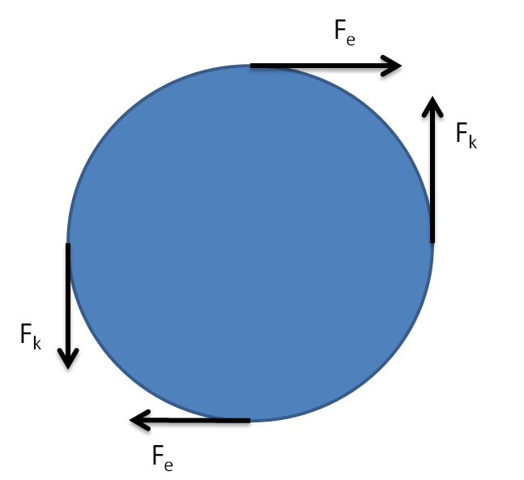

Since all forces are applied at a distance from the axis of rotation, the equation of motion can be written in terms of torques:

where is the torque due to the electromagnet, is the torque due to the spring, is the torque due to the dampening material properties of the bowl and spring, is the moment of inertia of the bowl, and is angular acceleration. The torque due to the electromagnet can be determined by the following equation:

where is the radius at which the electromagnet’s armature is mounted. The electromagnetic force can be described by the expression:

where is the inductance of the electromagnet. The partial derivative can be evaluated by the equation:

Where and are constants related to the form of the electromagnetic coil. Substituting this expression into the electromagnetic force equation yields the expression:

In the expression above, the current within the coil can be adjusted to change the electromagnetic force. Consequently, the power circuit used to drive the electromagnet can be designed to adjust the current within the electromagnet and easily control the input force for the system.

With the input force defined, other forces within the system need to be further refined. The spring’s torque can be described by the following expression:

Lastly, the torque due to dampening can be described as:

These expressions for torque can be substituted into the equation of motion to yield the equation:

Since the spring and electromagnet will be mounted at the same radius from the center of rotation, will be equal to . Furthermore, the system is being designed to control the tangential acceleration of the parts on the outside of the bowl. As a result, is equal to and . Consequently, the system can be simplified and solved for . Solving for tangential acceleration produces the expression:

With the equation of motion created, the system is now ready to be put into state space form. The state space variables, and , can be defined as follows:

The system can now be transformed into state space form which yields the expression:

With the state space equation defined, the system can be simulated and the feasibility of moving the parts through the system can be determined. MATLAB was used to simulate the impulse response and frequency response of the system. Using conservative coefficients for the spring

constant, damping constant, and the moment of inertia computed from the CAD model, the impulse response and frequency response was plotted. The frequency response of the system is shown in the Bode Diagram. The impulse response is shown in the Step Response graph.





In the frequency response, the system is observed to have a peak at 28 Hz. Consequently, the system is observed to be operable between 20-40Hz as was desired. Furthermore, the spring characteristics can be tuned to produce a higher or lower operating frequency. From the impulse response, the tangential velocity of the parts on the outer most edge of the bowl can be observed to receive 0.25 m/s from an input force of 1 N. Consequently, the input force can be increased to increase the velocity of the parts so that the parts reach the counting mechanism in sufficient time. With the system’s resonant frequency tunable and the parts’ velocity able to be controlled by the input force, the feasibility of moving the parts with sufficient velocity through the system with electromagnetic and spring components has been deemed possible.

Financial Feasibility

The overall cost of the system will be determined by the building materials, microcontroller, and the electromagnets to power the system. For building materials, the bowl is planned to be 3D printed from ABS plastic. A 1kg reel of ABS plastic can be purchased at Microcenter for $15.99. Additionally, the frame will need to be built out of aluminum angle pieces. These pieces can be purchased in lengths of 96 inches for $18.54. We anticipate the need for 13 feet of aluminum angle for the frame and mounting pieces. The microcontroller we will be using retails for $19.99. Lastly, sufficient electromagnets such as a 50kg holding force magnet cost $19.29. The sum of these materials for the build adds to $111.64. An additional $50 should be allotted for other expenditures for prototyping and other small components. Even with this extra allowance for additional parts, the system falls well within reasonable financial limits.

**Potential Markets and Applications**

The system could efficiently and accurately count parts needed by an assembly worker and dispenses those parts into a worker’s awaiting hand. This kind of function can be applied in many related fields and across several industries. One such field that would greatly benefit from this type of device is manufacturing. As manufacturing facilities become more advanced the need to save on time in the form of throughput and money in the form of fastener and raw build material will become more important. A similar device as this one, if properly deployed, could save a firm both in terms of time and money. Another area that could benefit from this design would be hardware distributors. Hardware typically comes in a bag of anywhere from 2 to 20 parts, various kinds of fasteners.

Before packaging, catching the exactly number of parts to be packaged is important. Instead counting the parts by human being, which is grossly prone to error, a machine could proper do the work effectively and accurately. Additionally, the machine can count different types and different numbers of small parts by easily changing or adjusting the components.

Although the system is now just suitable for no more than 50 parts, it can be developed to fit more parts to work better in the real industry. Further, this vibration system also can not only used to count one kind of parts, after some changes, it also can be used to classify different kind of parts, which will be very useful in cross industry applications.

Another market that could find benefit from such a device is the pharmaceutical market. From pill factories to the local pharmacy, accurate counting of one’s medicine has always been a critical task. When left in the hands of this machine that task is made more certain to be done right every time.

**Project Timeline**



**Appendix: System Requirements**

**Fall 2014 Senior Project**

**System Requirements**

**Group 2**

**V1.0**

September 7, 2014

**Revision History:**

|  |  |  |
| --- | --- | --- |
| **Version** | **Comments** | **Updated By:** |
| 1.0 | Initial release | P. Kruchko |
|  |  |  |
|  |  |  |
|  |  |  |
|  |  |  |
|  |  |  |
|  |  |  |
|  |  |  |
|  |  |  |
|  |  |  |
|  |  |  |
|  |  |  |
|  |  |  |
|  |  |  |
|  |  |  |
|  |  |  |
|  |  |  |

**Overview**: For the Fall 2014 semester, we will build, test, and compete with devices that will count small parts (screws, bolts, nuts and other fasteners) and deliver them upon request, with the goal to immediately deliver the exact number of parts when they are requested.[1]

**Objective of document:** To capture, define, and refine customer requirements to derive a set of specific system level requirements from which the more detailed aspects of the system can be identified to further and more accurately specify the electrical, mechanical, and computational needs of the system that must be met in order to implement a product that satisfies the customer requirements.

**Scope:** To provide the initial framework for Group 2 to further refine the requirements of the system so that an accurate system architecture and model can be subsequently created.

[1] Taken from Senior Design Syllabus, per Dr. Michael Latcha.

**Glossary of terms:**

Architectural Requirements: Describes what has to be done by identifying the necessary system architecture.

Functional Requirements: Describes the functionality that the system is to execute.

Non-Functional Requirements: Describes characteristics of the system that the user cannot affect or immediately perceive.

Constraint Requirements: Identifies the limits imposed upon the design that system must operate within.

|  |  |  |  |
| --- | --- | --- | --- |
| Acronym | Term | Example |  |
| FR-X | Functional Requirement, numbered X | FR-1 |  |
| AR-X | Architectual Requirement, numbered X | AR-1 |  |
| CR-X | Constraint Requirement, numbered X | CR-1 |  |
| NFR-X | Non-Functional Requirement, numbered X | NFR-1 |  |
| TBR | To Be Refined-Need to know more specific info | Qty.(4) 6 mm hex nuts |  |
|  |  |  |  |
|  |  |  |  |

**Table of Requirements:**

|  |  |  |  |
| --- | --- | --- | --- |
| **Requirements Tag** | **Description** | **Requirement** | **TBR** |
| FR-1 | Types of parts to be dispensed | The system shall dispense a variety of 5-6 different types of small mechanical fasteners such as screws, bolts, nuts, washers and plastic trim pieces | What kind of parts? Need to know the exact types of parts that are going to be included in the spectrum of parts to be dispensed. i.e. hex nuts, wing nuts, flat washers, spring washers, etc. |
| AR-1 | Size and form factor of system | The system shall be small, adaptable, and configurable | How small? What are the minimum and maximum dimensions that the system should be? Adaptable to what type of conditions? How configurable? Manually configurable or automatically configurable? What does it have to be configured for? What does it have to be configured to do? |
| FR-2 | Amount of parts to be dispensed | The system shall dispense between 1-6 of the small parts on a given dispense cycle |  |
| FR-3 | Adjustment for quantity | The system shall be easily adjusted to dispense the desired amount of parts | How adjusted? What is the user interface for part quantity adjustment? |
| FR-4 | Accommodation of size of parts | The system shall accommodate different sizes for the parts to be dispensed | What is the minimum size? What is the maximum size? What are the dimensions of the trim pieces to be dispensed? |
| CR-1 | Dispense Cycle Time | The system shall perform one parts dispense cycle within 30 seconds. With a dispense cycle being defined as beginning with the user interaction with the system and ending when the system dispenses the parts into the hands of the user |  |
| FR-5 | Delivery Mechanism | The system shall dispense the parts to the user's opened hand by mass transport through a chute system | To refine the dimensions and material of the chute system. Also angle of it's major line of axis and position with respect to the base of the system. |
| FR-6 | Method of part storage | The system shall store the parts to be dispensed in a container | What are the dimensions of the container? What material shall the container be constructed from? How is the container fastened to the system's machine frame? |
| CR-2 | Number of dispense cycles | The system shall perform at least 3 dispense cycles |  |
| FR-7 | Total quantity of parts that need to be dispensed from the system | The system shall be able to store enough parts to be able to meet the maximum possible amount of parts that can be dispensed for a given dispense cycle i.e. 3 dispense cycles and 6 parts maximum = 18 parts minimum that the system needs to be able to dispense |  |
| CR-3 | Accuracy of dispense cycle | The system shall be 100% accurate in quantity of parts dispensed per user input 100% of the time. |  |
| AR-2 | System power |  | What is to be the power source for the system? |
| CR-4 | System power constraints |  | What is the maximum voltage that the system should operate at? Minimum voltage? What is max constant current draw of the system? What is the max peak current draw for the system? |